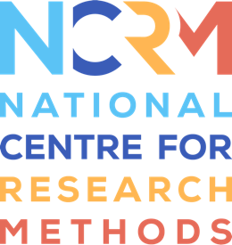
Corpus-Assisted Discourse Studies (CADS)

Worksheet for video 4

Full resource, see: https://www.ncrm.ac.uk/resources/online/all/?id=20855

In Video 4, you’ll look at some data taken from a CADS research project which explores a corpus of 50 Young Adult fiction novels and compares female authors’ books with those of male authors to see the differences in writing topics and styles. I’m carrying out this work with fellow researchers Sarah Mukherjee and Sally Hunt. The aim of the project is to uncover differences in the worldviews presented by each author group, as YA fiction is an important reflective space for young people.

TASK 1: Categorising keywords
Look at the list of keywords below. They are all significantly more frequent in work by female writers of YA fiction when compared to male writers of YA fiction. Try to devise five thematic category labels and place the words into these categories. An example category has been given to start you off (though you can change this if you like).
Keywords
bends, brace, breathes, brushes, clenches, crown, dagger, duffel, emails, frowns, glances, gloves, grins, guards, hem, hoodie, laughs, media, microphone, murder, peers, recording, shifts, shrugs, stares, sword, training, trial, tugs,

Thematic category | Keywords
Clothes | crown, gloves...

Once you’ve had a go, look over the page for a suggested categorisation.

TASK 2: Analysing concordance lines
In Task 1, you focused on words which were key in female-authored YA fiction when compared to male-authored YA fiction. For this task, you’ll look at concordance lines within one keyword category across both author groups.
Part A
First, look at the keywords below. Write down anything you notice about the type of words in each group.
Key Category | Female-authored | Male-authored
Physical actions & movement | bends, brace, brushes, clenches, crosses*, fills, gulp, leans, motionless, presses, sends*, shifts, shrugs, tugs, twists, slams* | clambered, crouched, exploring, hopped*, knelt, pumping, scrambled, shrank, tiptoed, tumbled, woke

Notes

You can compare your thoughts with mine in the responses section.

Part B
Next, look at some of the concordance lines for words in each group – there is one example for 10 of the keywords in each group. What other differences do you notice between the two author groups?
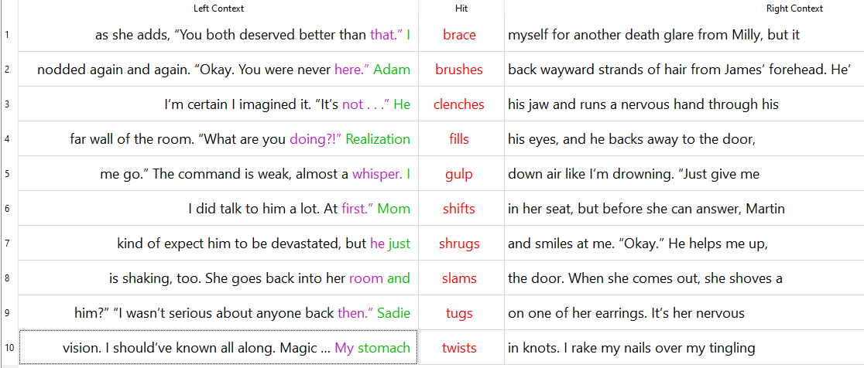
  - Physical Actions & Movement in female-authored YA fiction
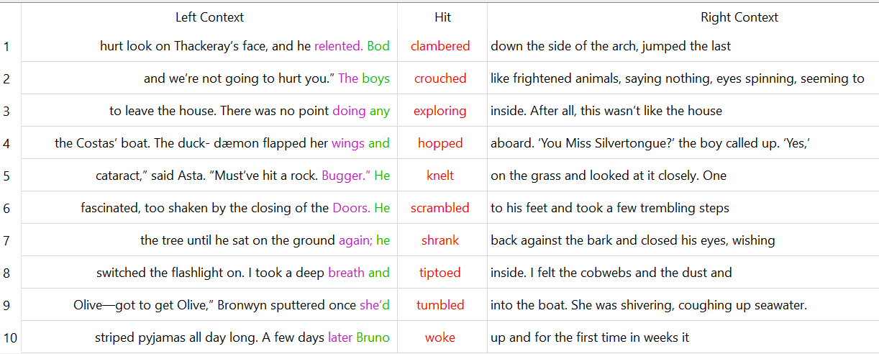
  - Physical Actions & Movement in male-authored YA fiction
Notes

Compare your response with mine at the end of the document.

Finally, if you’d like to learn more about this study on YA fiction, visit the project website here: Uncovering Discourses of Representation in Young Adult Fiction (DoRA) | Faculty of Wellbeing, Education and Language Studies

National Centre for Research Methods (NCRM)
Social Sciences
Murray Building (Bldg 58)
University of Southampton
Southampton SO17 1BJ
United Kingdom
Web www.ncrm.ac.uk
Email info@ncrm.ac.uk
Tel +44 23 8059 4539
Twitter @NCRMUK

TASK 1 - response
Here are the categories I selected. You may have categorised the keywords differently.
Key Category | Keywords
Clothing | crown, duffel, gloves, hem, hoodie
Conflict & struggle | dagger, guards, murder, sword, training, trial
Facial expressions | breathes, frowns, glances, grins, laughs, peers, stares
Technology | emails, media, microphone, recording
Physical actions & movement | bends, brace, brushes, clenches, shifts, shrugs, tugs

An important point to note is that you didn’t have the concordance lines to help you decide on the meanings in context so were only going by the words given. For example, you may have been unsure as to whether brace and brushes refer to verbs or to the objects. If you were analysing keywords you’d extracted from a corpus, you’d look at the concordance lines for each word, to check the meaning in context.

TASK 2 - response
Part A
You may have noticed that both groups of keywords contain mainly verbs, and that the female-authored verbs are present tense whereas the male-authored ones are past tense. Perhaps there is more dialogue – written in the present tense – in the female-authored books. Additionally, the female-authored verbs tend to be smaller actions whereas the male-authored ones are larger actions involving movement. It would be worth looking into any differences in the use of dialogue – perhaps by searching each corpus for quotation marks.

Part B
In the female-authored corpus, words in this category appear to reveal character feelings through their actions, whether actual (e.g. lines 2 and 6 ) or more likely figurative (e.g. lines 4 and 10). The author’s choice to describe minor actions such as brushing back a strand of hair or tugging on an earring serves to illustrate a character’s inner world of emotions. This contrasts with the male keywords which tend to relate to large body movements. While some of these might indicate the character’s emotions (e.g. line 7), most appear to describe physical actions taken in the world by humans or animals (e.g. line 4).

